41 UC Sửa hóa đơn

42 UC Xem hóa đơn

43 UC Cập nhật hóa đơn

44 UC Xóa hóa đơn

45 UC Thống kê báo cáo khách hàng

46

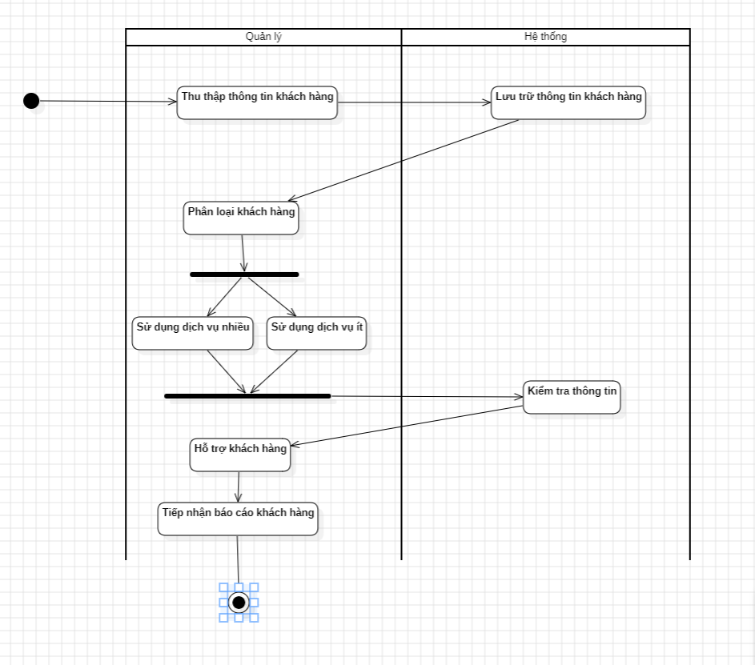

47

48

49

50

31

52

